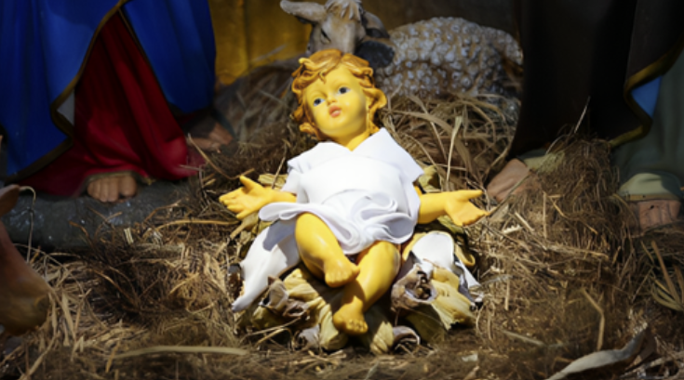

CHRISTMAS MESSAGE 2024

Dear Friends in Christ,

This Christmas, like all those before, is a celebration of joy and hope, as it proclaims the wondrous love of God for us. In a Christmas homily a few years ago, Pope Francis reminded us that the birth of Christ brings people hope and courage in troubled times. A Christmas carol lyric puts it even more poetically: “the hopes and fears of all the years are met in thee tonight.” The coming of God to redeem us, promised so long ago, proclaims that we are precious and beloved. This knowledge invites us to face the future with courage and confidence, despite any challenges or fears that may afflict us.

The theme of hope is even more pronounced this Christmas, as Pope Francis will inaugurate the Jubilee year on Christmas Eve at St. Peter’s Basilica in Rome. The Church celebrates such Jubilees every twenty-five years, and the Holy Father has declared this holy year to be a Jubilee of Hope. We are invited, with the universal Church, to embark on this celebration, and to embrace the great virtue of hope – one that will be lived out in our desire for peace, our respect for life and our loving care for those who suffer in any way.

The Solemn Opening of the Jubilee in our diocese will take place at the Cathedral of St. Peter-in-Chains on the Feast of the Holy Family, Sunday, December 29 at the 10:30 a.m. Mass, an event that I am looking forward to celebrating. Though it is a busy time of year and not all of you live close to Peterborough, I invite and encourage you to join me for this Mass, as we initiate the Jubilee of Hope in our diocese.

May this great Christmas season, when we celebrate God’s love revealed in “a child born for us,” instill in our hearts an ever-deeper hope and inspire us to bring hope to others. May the joy of Christ’s birth, the foundation of our hope, be with you and yours this Christmas.

Yours in Christ,
+Daniel Miehm
Bishop of Peterborough

